HTML

Structure/layout

CSS JS

Style Logic

  

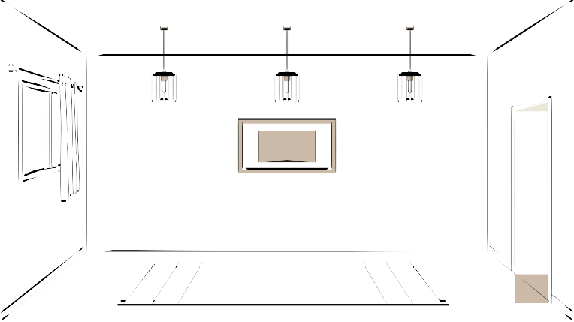

Level 1



HTML

Hyper Text Markup Language

HTML is the code that is used to structure a web page and its content.

The component used to design the structure of websites are called HTML tags.

First HTML File

index.html

It is the default name for a website's homepage

HTML Tag

A container for some content or other HTML tags

<p>

This is a paragraph

Element

Content

</p>

Basic HTML Page

<!DOCTYPE html>

<html>

<head>

tells browser you are using HTML5 root of an html document container for metadata

<title>My First Page</title>

</head>

page title

<body>

<p>hello world</p>

</body>

</html>

contains all data rendered by the browser paragraph tag

Quick Points

Html tag is parent of head & body tag

Most of html elements have opening & closing tags with content in between

Some tags have no content in between, eg - <br>

We can use inspect element/view page source to edit html

Comments in HTML

This is part of code that should not be parsed.

<!-- This is an HTML Comment -->

HTML is NOT case sensitive

<html> = <HTML>

<p> = <P>

<head> = <HEAD>

<body> = <BODY>

Level 2

Basic HTML Tags

HTML Attributes

Attributes are used to add more information to the tag

<html lang="en">

Heading Tag

Used to display headings in HTML

h1 (most important)

h2 h3 h4 h5

h6 (least important)

Paragraph Tag

Used to add paragraphs in HTML

<p> This is a sample paragraph </p>

Anchor Tag

Used to add links to your page

<a href="https://google.com"> Google </a>

Image Tag

Used to add images to your page

<img src="/image.png" alt="Random Image">

relative url

Br Tag

Used to add next line(line breaks) to your page

<br>

Bold, Italic & Underline Tags

Used to highlight text in your page

<b> Bold </b>

<i> Italic </i>

<u> Underline </u>

Big & Small Tags

Used to display big & small text on your page

<big> Big </big>

<small> Small </small>

Hr Tag

Used to display a horizontal ruler, used to separate content

<hr>

Subscript & Superscript Tag

Used to display a horizontal ruler, used to separate content

<sub> subscript </sub>

H O

2

<sup> superscript </sup>

n

A + B

Pre Tag

Used to display text as it is (without ignoring spaces & next line)

<pre> This

is a sample text.

</pre>

Level 3

Page Layout Techniques

using Semantic tags for layout

using the Right Tags

<header>

<main>

<footer>

Inside Main Tag

Section Tag

<section>

For a section on your page

Article Tag

<article>

For an article on your page

Aside Tag

<aside>

For content aside main content(ads)

Revisiting Anchor Tag

<a href="https://google.com" target="_main"> Google </a>

for new tab

<a href="https://google.com"> <img src="link"> </a>

clickable pic

Revisiting Image Tag

<img src="link" height=50px >

set height

<img src="link" width=50px >

set width

Div Tag

Div is a container used for other HTML elements Block Element (takes full width)

List : Div Tags

<address>

<article>

<aside>

<blockquote>

<canvas>

<dd>

<div>

<dl>

<dt>

<fieldset>

<figcaption>

<figure>

<footer>

<form>

<h1>-<h6>

<header>

<hr>

<li>

<main>

<video>

Span Tag

Span is also a container used for other HTML elements Inline Element (takes width as per size)

List : Span Tags

<a>

<abbr>

<acronym>

<b>

<bdo>

<big>

<br>

<button>

<cite>

<code>

<dfn>

<em>

<i>

<img>

<input>

<kbd>

<label>

<map>

<object>

<tt>

<var>

<time>

Level Pro

List in HTML

Lists are used to represent real life list data.

unordered ordered

<ul>

<li> Apple </li>

<li> Mango </li>

<ol>

<li> Apple </li>

<li> Mango </li>

</ul> </ol>

Tables in HTML

Tables are used to represent real life table data.

<tr> used to display table row

<td>

<th>

used to display table data used to display table header

Tables in HTML

1664

Purva

Roll No

Name

<table>

<tr>

<th> Name </th>

<th> Roll No </th>

</tr>

<tr>

<td> Purva </th>

<th> 1664 </th>

</tr>

</table>

Caption in Tables

<caption> Student Data </caption>

Student Data

Name

Purva

Roll No

1664

thead & tbody in Tables

<thead> to wrap table head

<tbody> to wrap table body

colspan attribute

colspan="n"

used to create cells which spans over multiple columns

Data

Aman

1890

1664

Purva

Form in HTML

Forms are used to collect data from the user Eg- sign up/login/help requests/contact me

<form>

form content

</form>

Action in Form

Action attribute is used to define what action needs to be

performed when a form is submitted

<form action="/action.php" >

Form Element : Input

<input type="text" placeholder="Enter Name">

Label

<label for="id1">

<input type="radio" value="class X" name="class" id="id1">

</label>

<label for="id2">

<input type="radio" value="class X" name="class" id="id2">

</label>

Class & Id

<div id="id1" class="group1">

</div>

<div id="id2"> class="group1">

</div>

Checkbox

<label for="id1">

<input type="checkbox" value="class X" name="class" id="id1">

</label>

<label for="id2">

<input type="checkbox" value="class X" name="class" id="id2">

</label>

Textarea

<textarea name="feedback" id="feedback" placeholder="Please add Feedback">

</textarea>

Select

<select name="city" id="city">

<option value="Delhi"> Delhi </option>

<option value="Mumbai"> Delhi </option>

<option value="Banglore"> Delhi </option>

</select>

iframe Tag

website inside website

<iframe src="link"> Link </option>

Video Tag

<video src="myVid.mp4"> My Video </video>

Attributes

* controls
* height
* width
* loop
* autoplay

Thank you